[POSOT] – Reporting 
CONTACTS/Doc Info
ROLE | Name: Alias
Author | Adarsh Devashish (v-adevashish)
Reviewer | Sumit Kandwal (v-skandwal)
Sign-off provider | Soham Kishor Butala (v-sbutala)
Version | 1.0

PROJECT INFO | Value
ADO Item | Business Scenario 30244: Co-Marketing Geo Perspective Incremental Enhancements

Table of Contents
Approach Document ...........................................................................................................................3
BRD Location .................................................................................................................................... 3 Business Request .............................................................................................................................. 3 Approach........................................................................................................................................... 3 Approach for Ingestion of GSI and GSDC split...................................................................................... 3
Approach for drill down analysis of Investment Ask and Investment Spend............................................ 6
Clarification ………………......................................................................................................................7
Dependency and Impact......................................................................................................................7
Source Mapping ..................................................................................................................................7 Changes required for Reporting and Downstream ….............................................................................7

Approach Document

BRD Location
Business Scenario 30244: Co-Marketing Geo Perspective Incremental Enhancements

Business Request –
The objective of this business scenario is to enable detailed drill-down analysis of Investment Ask and Investment Spend for any selected Partner across dimensions such as Solution Area, Date/Time, Geo, and other available Investment attributes. Additionally, the scenario seeks to ingest the FY26 Co-Marketing budget split for GSI and GSDC and integrate it into the reporting model, allowing users to slice, filter, and visualize the updated budget distribution at a month-level.

Approach –

Approach for Ingestion of GSI and GSDC split –
- Uploading the Excel to Lakehouse (Files Section)
We will ingest the provided GSI–GSDC split Excel file and store it in the Files area of the Lakehouse for further processing.
Steps to Implement:
- Receive the updated FY26 Co-Marketing budget Excel file containing GSI & GSDC split.
- Navigate to the Lakehouse > Files section.
- Upload the Excel into the appropriate folder (/Files/CSV/Comarketing TPM Budget FIle.xlsx).
- Validate file structure:
  - Sheet name
  - Column names
  - Data types
  - No missing mandatory fields
- Creating a Table on Top of the Excel File
We will load the Excel from the Files area and create a table inside the Lakehouse SQL Endpoint, named ComarketingTPMBudget .
Detailed Steps
- Access Notebook or SQL Endpoint to read the Excel from Files.
- Convert the Excel content into a DataFrame.
- Apply data type standardization and cleanup:
  - Date → Date type
  - Numeric columns → Double/Decimal
  - GSI/GSDC columns → Integer/Decimal
- Create or replace the table under the target Schema.
CODE:
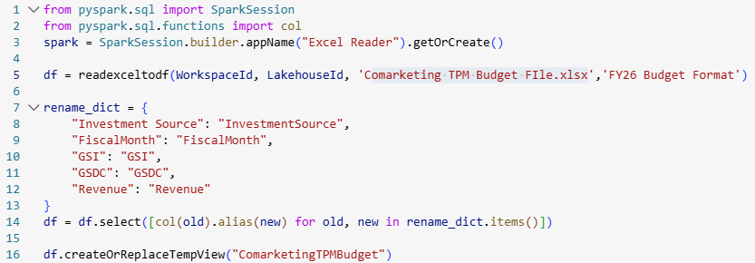

- Onboarding New Columns (GSI & GSDC) into Semantic Model
Once the table is created, we will update the semantic model to incorporate the new columns.
Detailed Steps
- Go to Power BI dataset / semantic model connected to the Lakehouse.
- Refresh the schema to detect the updated table structure.
- Add the following fields:
  - GSI
  - GSDC
- Add metadata:
  - Display name
  - Descriptions
  - Formatting (percentage or numeric)

- Reporting the GSI and GSDC Split in the Report
The final output must allow users to slice revenue metrics using GSI/GSDC values.
Detailed Steps
- In the report canvas, add a slicer visual with:
  - GSI
  - GSDC
- Build logic to filter Revenue metrics based on selected split:
  - When GSI is selected → Revenue visuals recalculate using GSI distribution
  - When GSDC is selected → Revenue visuals adapt to GSDC weightage
- Validate cross-filtering between:
  - Partner
  - Solution Area
  - Geo
  - Month
  - Investment attributes

Approach for drill-down analysis of Investment Ask and Investment Spend
1. Create a Dedicated “Investment Details” Page
Build a separate report page focused entirely on granular investment insights.
Detailed steps:
- Add new visuals such as:
  - Detailed grid tables showing line-level Investment Ask / Investment Spend records.
  - Breakdown charts (bar, matrix, line) for Spend by Month, Geo, Solution Area, and Investment Type.
  - Partner-specific detail views to support deep exploration when a partner is selected.
- Include supporting attributes such as:
  - <TBD>
  - <TBD>
  - <TBD>
- Apply clean formatting, conditional formatting (if needed), and ensure visuals support row-level drill-through.
This page will act as the central hub for detailed analysis once a user drills down from the summary dashboards.

2. Enable the Page as a Drill-Down / Drill-Through Target
Allow users to move seamlessly from summary dashboards → detail view.
Detailed steps:
- Enable “Drill-through” on the Investment Details page.
- Add drill-through fields such as:
  - PartnerOneNameID
  - Solution Area
  - Fiscal / Calendar Month
  - Subsidiary
  - Investment Attribute fields
- Set the page to “Keep all filters” so context is preserved.
- Configure visuals on the summary pages to support:
  - Right-click → Drill-through
  - Drill-down via hierarchy (e.g., Global → Area → Country → Partner)
- Validate the navigation flow:
  - Select a Partner → Drill-through → Investment Details
  - Select a Month → Drill-through → Investment Details
  - Select a Solution Area → Drill-through → Investment Details
This ensures users can jump to detailed insights without manually re-applying filters.

3. Add Key Dimensions and Ensure Filter Context Carry-Over
Make sure that all dimensions used in high-level visuals also propagate to the detailed page.
Detailed steps:
- Add the following dimensions into the model if not already included:
  - PartnerOneNameID
  - Solution Area
  - Fiscal Month/Year
  - Subsidiary
  - Investment attributes
- Ensure relationships between these dimensions and Fact tables:
  - Validate one-to-many / many-to-many behavior.
  - Ensure active relationship with the investment fact table.
- Test the behavior:
  - Select filters on the summary page → Drill-through → Confirm the same filters remain active on detail page.
- Enable sync slicers where required.
This guarantees precise contextual analysis, meaning users always view Investment Ask and Spend in the correct filtered context.

Clarification-
We need a confirmation of the newly added visuals and the dimension columns that will be used as filters on the Investment Details page.

Dependency and Impact
NA

Source Mapping
NA

Changes required for Reporting and Downstream
NA

